**AAC Exam : CIE-1**

**Project Title :** Healthcare Support System for Rural Area (HSSRA)

**Group Members** :

1. 20SOECE11045 - Yash Majithiya

**Email** : ymajithiya905@rku.ac.in

**Contact No** : 7874599900

1. 21SOEIT13003 - Tulsi Chhatriwala

**Email** : tchhatriwala507@rku.ac.in

**Contact No** : 9484530655

----------------------------------------------------------------------------------------------------------------------------

**Project Definition Exploration**

1. Definition :Hospital Management System

This Website is made to solve the complications coming from managing all the paperwork of every patient associated with the various departments of hospitalization with confidentiality. This Website provides the ability to manage all the paperwork in one place, reducing the work of staff in arranging and analyzing the paperwork of the patients. Website does many works like:

Maintain the medical records of the patient

Maintain the contact details of the patient

Keep track of the Website appointment dates

Save the insurance information for later reference

Tracking the bill payments.

**Features:**

This Website is a computer system that helps manage the information related to health care and aids in the job completion of health care providers effectively. They manage the data related to all departments of healthcare such as,

Financial

Laboratory

Inpatient

Outpatient

Operation theater

1. Definition :Video/Status Downloader Website With Moderator

**Description:**

WhatsWebsite Status Full Video Uploader and Status Full Video Downloader is the best solution for those who want to Upload Status any favorite video song, any funny video or any long video on your social media account, so Status video uploader helps you upload your videos will be automatically split and full video will be set as your status you do not need to cut it manually .

If you want to download photos, GIFs, and videos from any friend's status, Status video downloader helps you download photo images, GIF, and videos from the status. If you want to Audio convert your favorite download Status Video, Status Full Video Uploader and Status Full Video Downloader helps you to convert your favorite Video Status into mp3. Status downloader as it helps your downloaded status automatically save to Gallery Website and android device Gallery. We provide different types of amazing functions that are best facilitated for android users and easily operated.Users Can Also Upload The short Videos and users can download it But Website Will Have One moderator So if any content violates any religious or any type of based content then moderator will remove it.

1. Definition :E-Banking

**Description:**

This Website would work as the moderator between the users and banks. The users can create and maintain their accounts, set or change passwords and avail themselves of the bank facilities without having to go there physically. They can transfer money online and their transactions will be saved in the Website. The Website will start out with a login screen, in which the user can either log in with an existing profile or click a button and create a new profile. When signed in, the user will be brought to their dashboard page and will be prompted to make their first account. Additionally, there will be a menu that includes all of the options for the Website, including Dashboard, Account Overview (and subsequently Transactions), Deposits, Payments, Transfers, Profile Settings, and Logout.

1. Definition :Train Food Website

**Description:**

Since not everyone likes the food served at railway stations, it is always a good option to order food online and make the journey even more pleasant. This Website would require three modules- the restaurant/café, the delivery person, and the passengers. All three would be able to log in to the Website. After logging in they will be prompted for user role selection.

Passenger: A passenger will see a home screen loaded with a variety of food items that they can order. Passengers would be able to see all their ordered items along with their status in a separate section. They would also see the current location of the delivery person.

Restaurant : If any restaurant logs in they will see some admin features like add a new food item, update details of existing items, mark unavailable any item, so on and so forth. Admins would be able to upload images of the food item while uploading details. Admins would be able to see placed orders and can accordingly prepare and deliver the food.

**Features:**

1. Online Transactions For ordering Food
2. Fast Delivery At Restaurant From Our Choice Hotels

### Providing Contact Information for the Delivery Person

### Food Delivery GPS Tracking in Real-Time

5. Definition : Job Portal With Expense tracker

**Description:**

There are Reasons to develop the new web-based Job-Portal system that helps in streamlining the flow of the job Website process. It allows users to select their roles (Websitelicant/recruiter), and create an account. In this web Website, login sessions are persistent and REST APIs are securely protected by JWT token verification. After logging in, a recruiter can create/delete/update jobs, shortlist/accept/reject Websites, view resume and edit profile. And, an Websitelicant can view jobs, perform fuzzy search with various filters, Website apply for jobs with an SOP, view Websites, upload profile pictures, upload resume and edit profile. Hence, it is an all in one solution for a job Website system and A expense trackers in which user can track their monthly expenses and can scale accordingly their business and they can check their Monthly reports also

**Features:**

* Job can be searched by the filters
* Recruiters can add jobs
* Applicants can Website apply for job online
* Applicants have to upload resume
* Filter for Jobs
* Monthly updates for jobs
* Freelancing work
* online updates on portal
* Personalize Dashboard
* Legal Information required for Employee
* Tracking income and expenses: Monitoring the income and tracking all expenditures (through bank accounts, mobile wallets, and credit & debit cards).
* Reports: The expense tracking Website generates and sends reports to give a detailed insight about profits, losses, budgets, income, balance sheets, etc.

**ER Diagram**

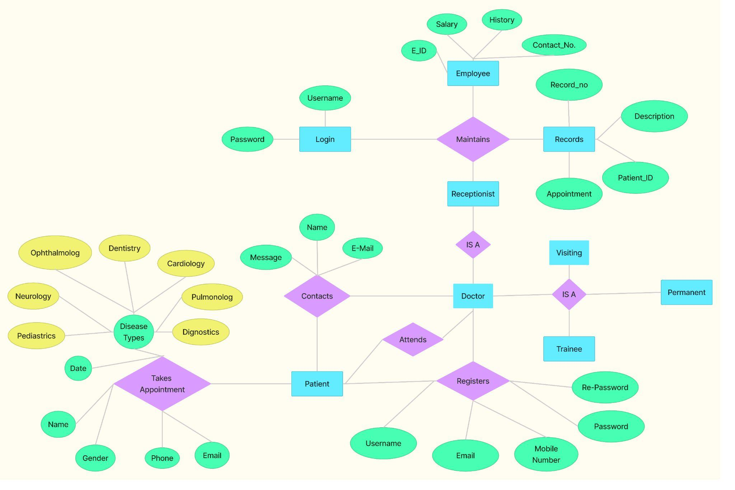

**Database Design Screens**

1. **Table Name :** UserTab

**Short Description**: This is the table in which all the users who are Registered to store the Details

**Screenshot**:

(a) Table Structure with Field Details

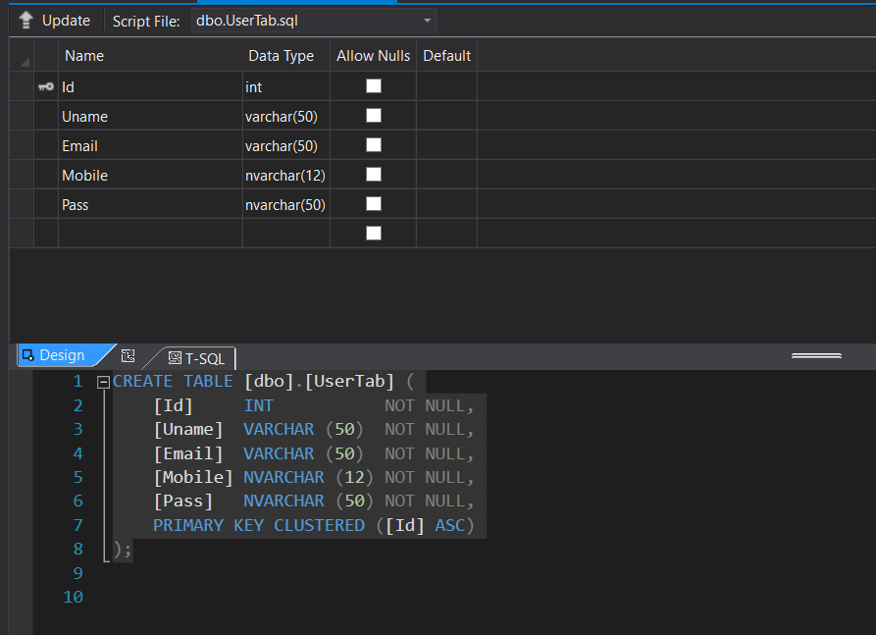

(b) Table with sample data

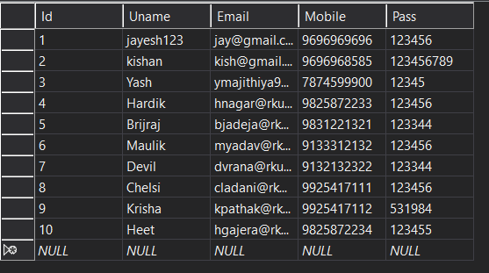

1. **Table Name :** FeedbackTab

**Short Description**: This is a Feedback Table in this all the Feedbacks Given on Website is stored

**Screenshot**:

(a) Table Structure with Field Details

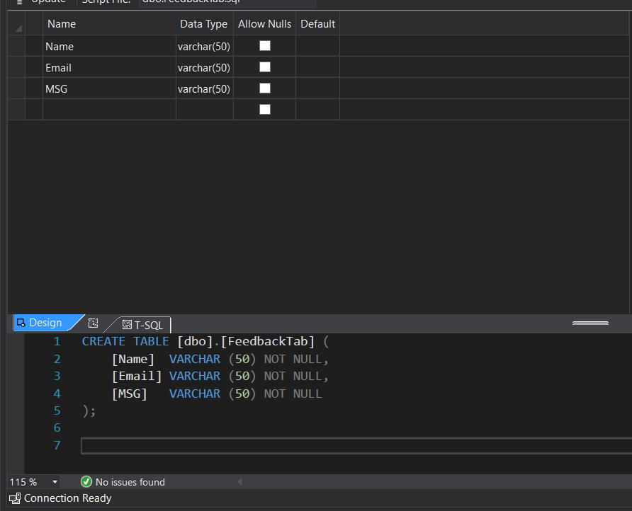

(b) Table with sample data

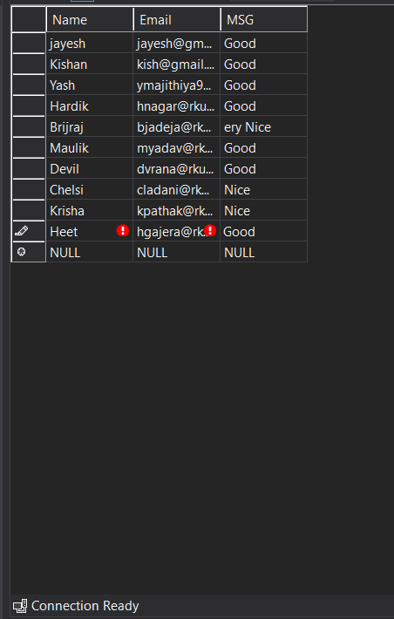

1. **Table Name :** Appointment Table

**Short Description**: This is the Appointment Table in this table when the user takes Appointment that data is stored

.

**Screenshot**:

(a) Table Structure with Field Details

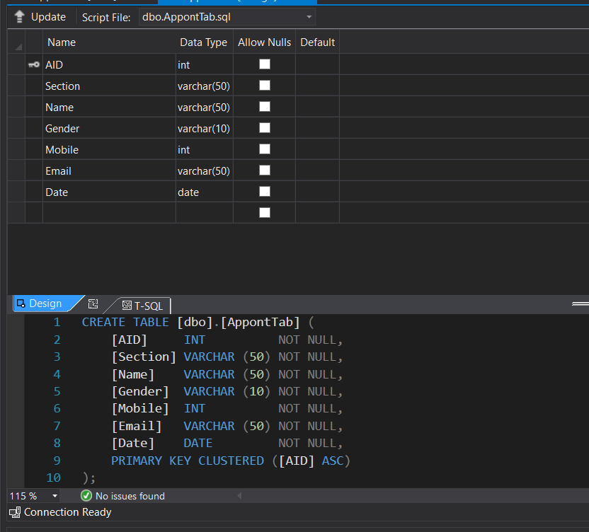

(b) Table with sample data

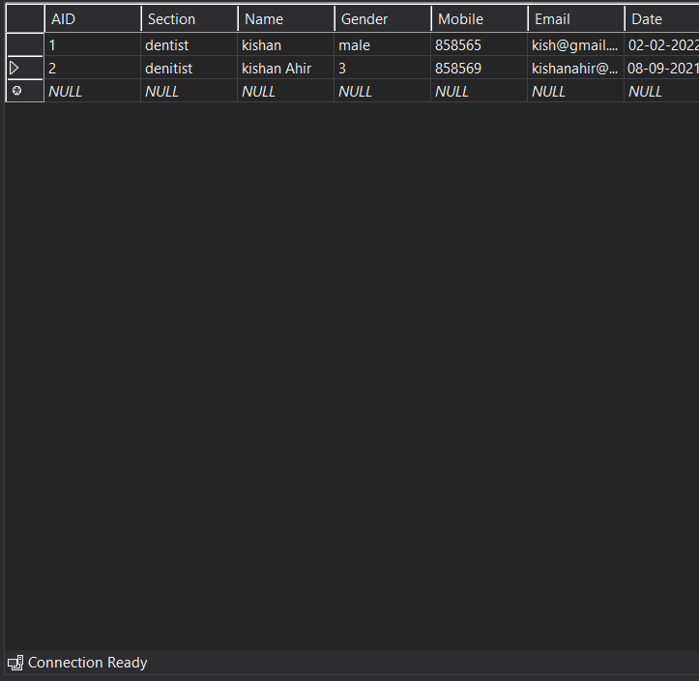

**UI Screens**

1. **Title :** Home page

**Short Description :** Users can go to the Home page, Appointment page, login, About Page, Gallery Page as well as contact here.

**Screenshot :**

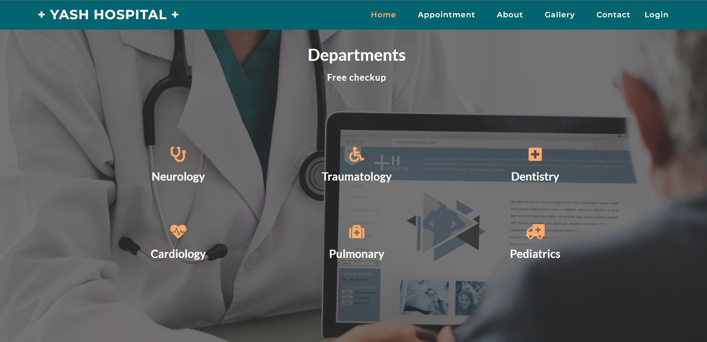

1. **Title :** Appointment Page

**Short Description**: Users can take the Appointment of the Doctor.

**Screenshot**:

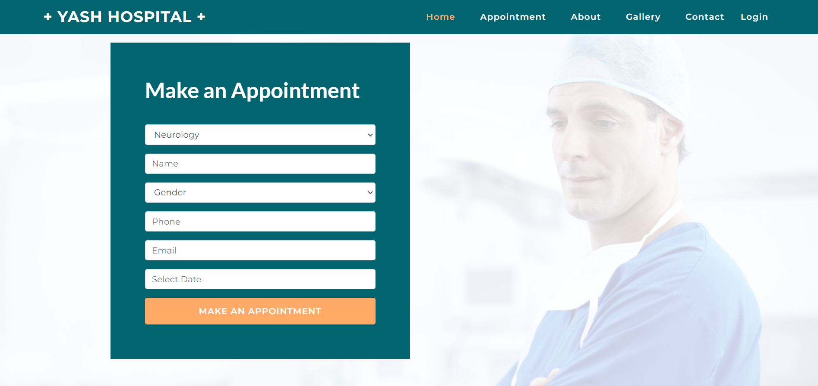

1. **Title :** About Page

**Short Description**: Users can take the Appointment of the Doctor.

**Screenshot**:

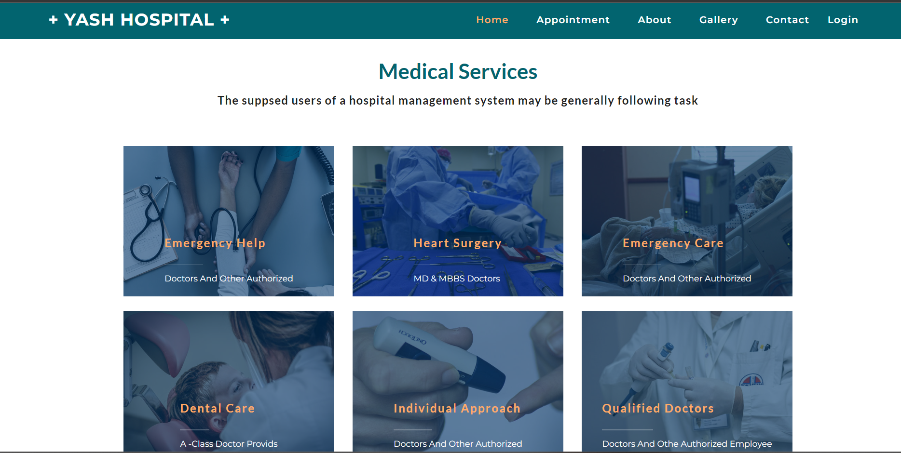

1. **Title :** Gallery Page

**Short Description**: Users can check the Photos.

**Screenshot**:

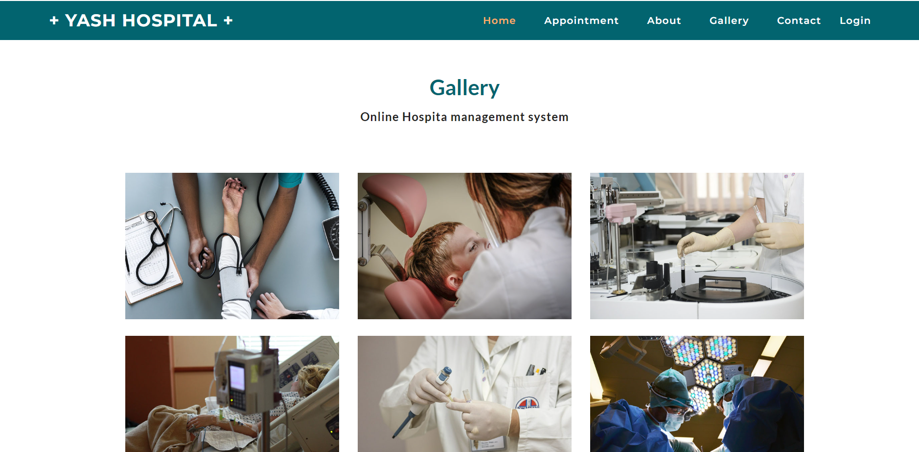

1. **Title :** Contact us Page

**Short Description**: Users can send a message to the Hospital for any type of queries.

**Screenshot**:

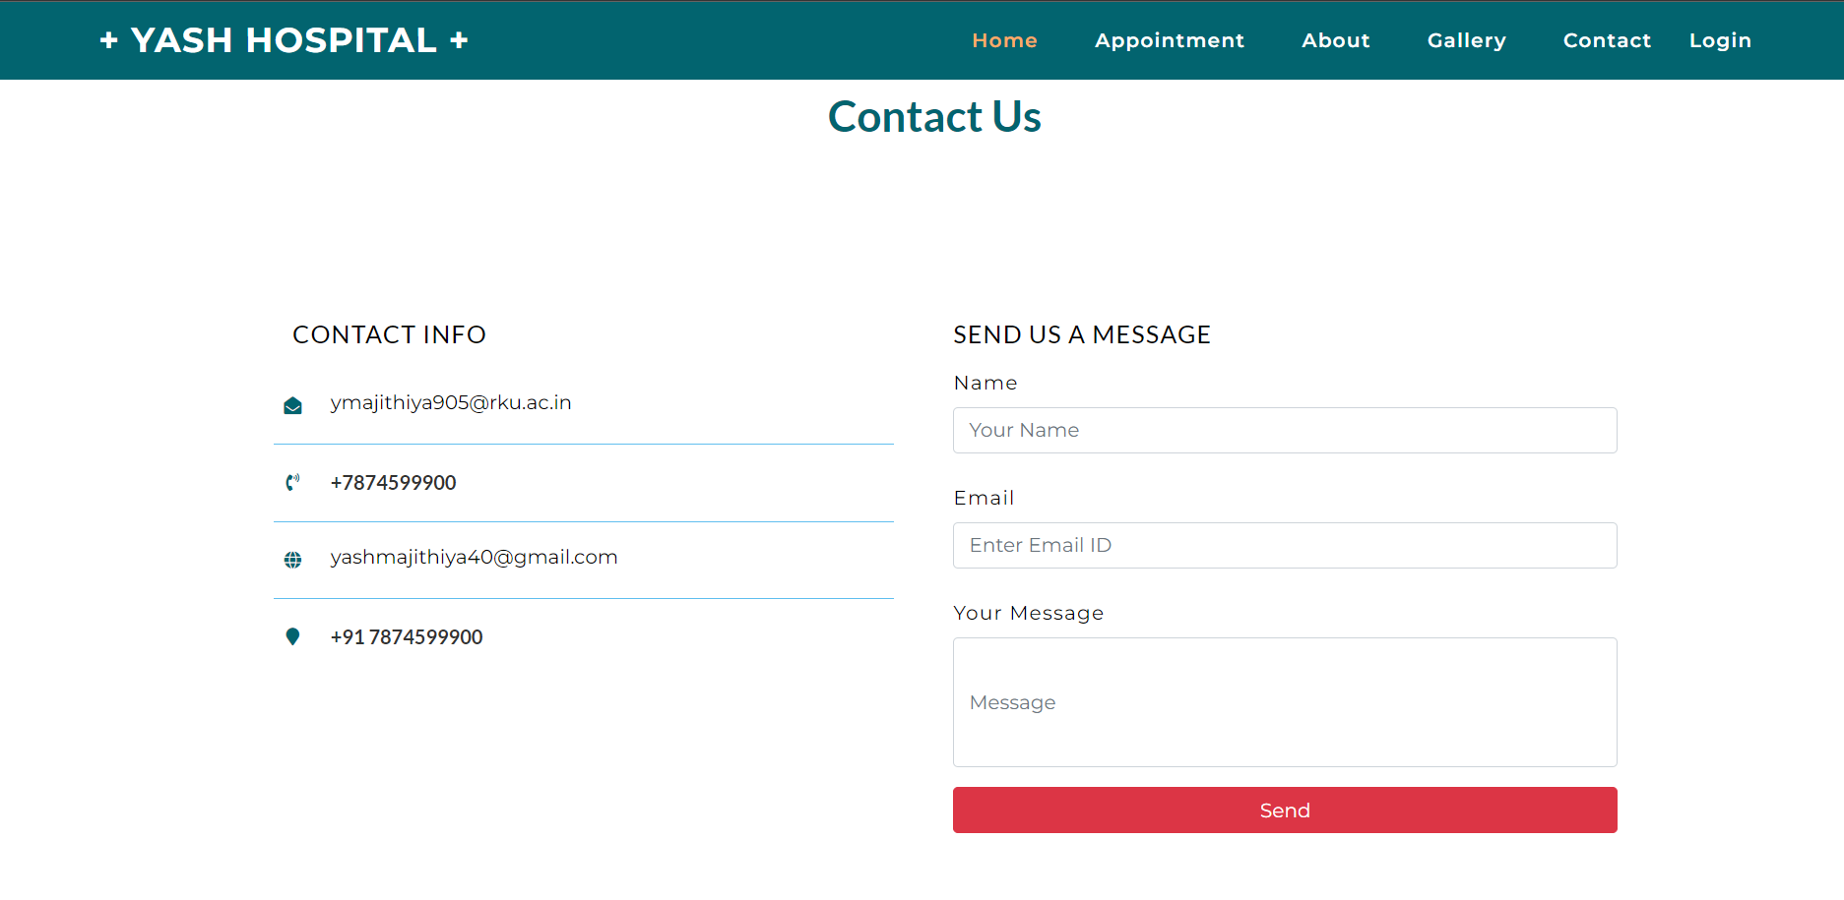

1. **Title :** LoginPage

**Short Description**: Users can Login from this page in to the Account

**Screenshot**:

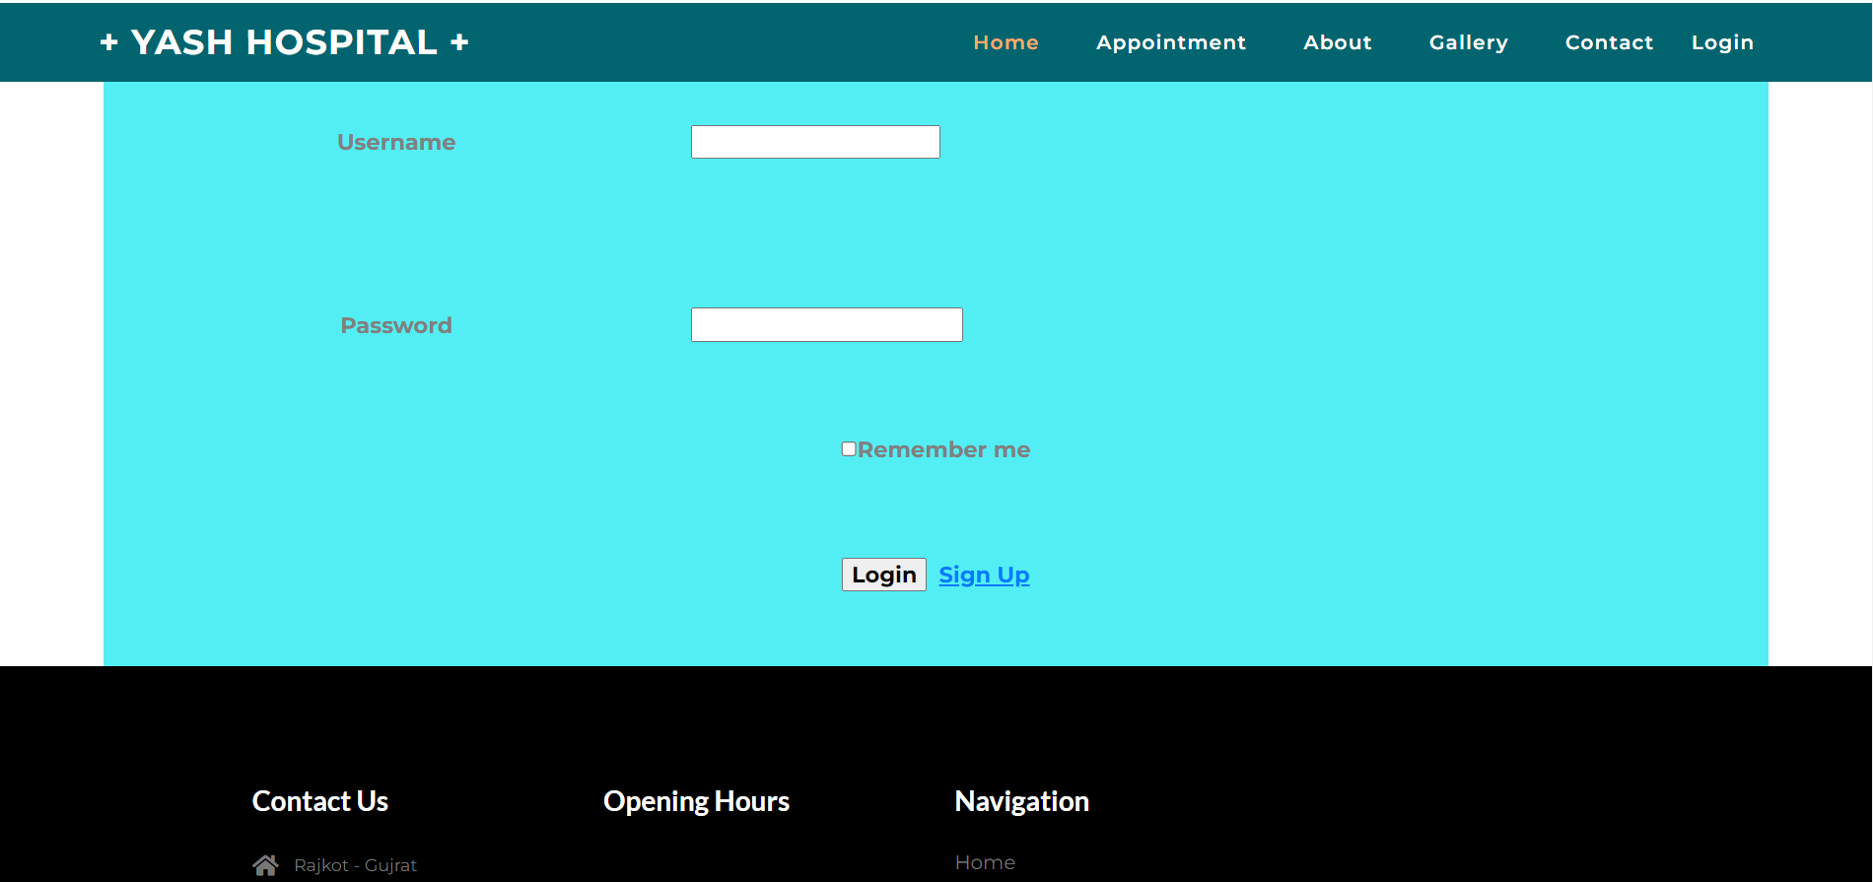

1. **Title :** SignUp Page

**Short Description**: Users can Create a new account if the Account Does not exist.

**Screenshot**:

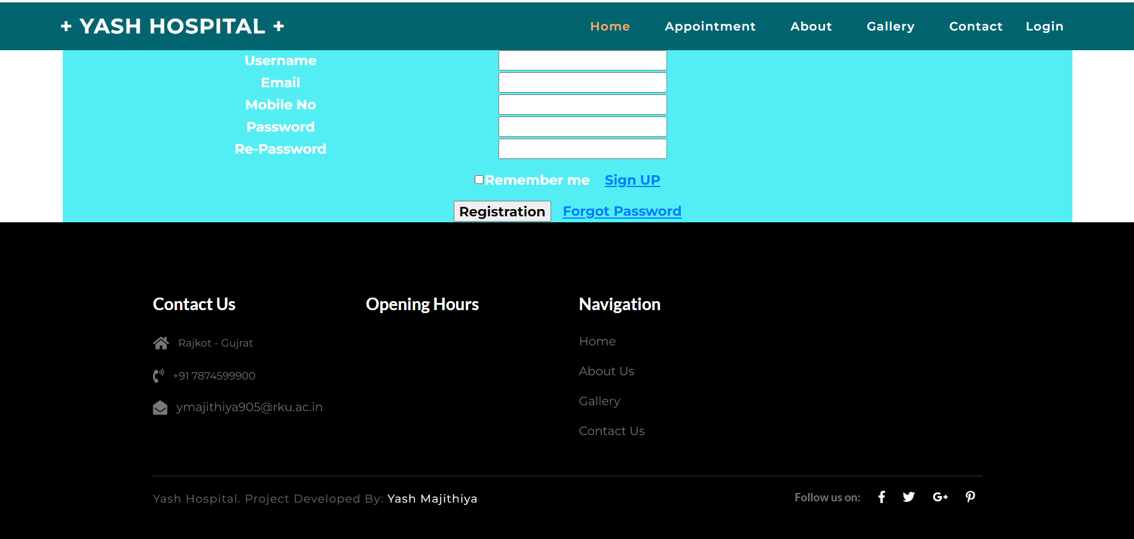

1. **Title :** Slider Page

**Short Description**: Users can check the social Accounts of hospital from here

**Screenshot**:

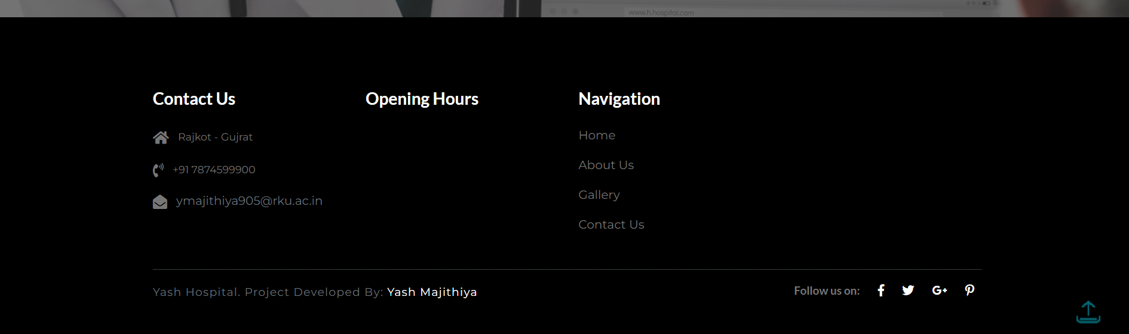

**UI Coding**

1. **Title :** Home page

**Short Description :** Users can go to the Home page, Appointment page, login, About Page, Gallery Page as well as contact here.

**ASPX Code :**

<%@ Page Title="Home" Language="C#" MasterPageFile="~/Users/usermaster.Master" AutoEventWireup="true" CodeBehind="Home.aspx.cs" Inherits="Hospital_management_System.Users.WebForm4" %>

<asp:Content ID="Content1" ContentPlaceHolderID="ContentPlaceHolder1" runat="server">

<div>

<section class="departments">

<div class="departments-1 py-lg-5">

<div class="container py-5">

<div class="text-center wthree-title pb-sm-5 pb-3">

<h3 class="w3l-sub text-white">Departments</h4>

<h4 class="sub-title py-3 text-white">Free checkup </h5>

</div>

<div class="row py-lg-5">

<div class="col-sm-4 w3-ab">

<div class="w3-ab-grid text-center">

<div class="w3-aicon p-4">

<i class="fa fa-stethoscope" aria-hidden="true"></i>

<h4 class="my-3 text-capitalize text-white">Neurology</h4>

</div>

</div>

</div>

<div class="col-sm-4 w3-ab">

<div class="w3-ab-grid text-center">

<div class="w3-aicon p-4">

<i class="fa fa-wheelchair" aria-hidden="true"></i>

<h4 class="my-3 text-capitalize text-white">Traumatology</h4>

</div>

</div>

</div>

<div class="col-sm-4 w3-ab">

<div class="w3-ab-grid text-center">

<div class="w3-aicon p-4">

<i class="fa fa-plus-square" aria-hidden="true"></i>

<h4 class="my-3 text-capitalize text-white">dentistry</h4>

</div>

</div>

</div>

<div class="col-sm-4 mt-4 w3-ab">

<div class="w3-ab-grid text-center">

<div class="w3-aicon p-4">

<i class="fa fa-heartbeat" aria-hidden="true"></i>

<h4 class="my-3 text-capitalize text-white">Cardiology</h4>

</div>

</div>

</div>

<div class="col-sm-4 mt-4 w3-ab">

<div class="w3-ab-grid text-center">

<div class="w3-aicon p-4">

<i class="fa fa-medkit" aria-hidden="true"></i>

<h4 class="my-3 text-capitalize text-white">pulmonary</h4>

</div>

</div>

</div>

<div class="col-sm-4 mt-4 w3-ab">

<div class="w3-ab-grid text-center">

<div class="w3-aicon p-4">

<i class="fa fa-ambulance" aria-hidden="true"></i>

<h4 class="my-3 text-capitalize text-white">pediatrics</h4>

</div>

</div>

</div>

</div>

</div>

</div>

</section>

</div>

</asp:Content>

**CS Code :**

1. **Title :** Appointment Page

**Short Description**: Users can take the Appointment of the Doctor.

**ASPX Code :**

<%@ Page Title="About" Language="C#" MasterPageFile="~/Users/usermaster.Master" AutoEventWireup="true" CodeBehind="Appointment.aspx.cs" Inherits="Hospital_management_System.Users.WebForm3" %>

<asp:Content ID="Content1" ContentPlaceHolderID="ContentPlaceHolder1" runat="server">

<div>

<div class="about">

<div class="abt-layer">

<div class="container">

<div class="about-main">

<div class="about-right">

<h3 class="subheading-w3-agile">Make an Appointment</h3>

<!-- stats -->

<div class="stats">

<div class="stats_inner">

<form action="#" method="post">

<asp:DropDownList ID="DropDownList_Section_1" class="form-control mb-3" runat="server">

<asp:ListItem Value="2">Neurology</asp:ListItem>

<asp:ListItem Value="3">Dentistry</asp:ListItem>

<asp:ListItem Value="4">Cardiology</asp:ListItem>

<asp:ListItem Value="5">Pediatrics</asp:ListItem>

<asp:ListItem Value="6">Pulmonolog</asp:ListItem>

<asp:ListItem Value="7"> Ophthalmolog</asp:ListItem>

<asp:ListItem Value="8">Diagnostics</asp:ListItem>

</asp:DropDownList>

<asp:TextBox ID="txt_Appoint_name_1" placeholder="Name" class="form-control mb-3" runat="server"></asp:TextBox>

<asp:DropDownList ID="DropDownList_gender_1" class="form-control mb-3" runat="server">

<asp:ListItem Value="2">Gender</asp:ListItem>

<asp:ListItem Value="3">Male</asp:ListItem>

<asp:ListItem Value="4">Female</asp:ListItem>

</asp:DropDownList>

<asp:TextBox ID="txt_Apoint_Mobile_1" class="form-control mb-3" placeholder="Phone" runat="server"></asp:TextBox>

<asp:TextBox ID="txt_Apoint_Email_1" class="form-control mb-3" placeholder="Email" runat="server"></asp:TextBox>

<asp:TextBox ID="datepicke1" class="form-control date mb-3" placeholder="Select Date" runat="server"></asp:TextBox>

<asp:Button ID="btn_Appointmnet_Submit" runat="server" class="btn btn-agile btn-block w-100" Text="Make An Appointment" OnClick="btn_Appointmnet_Submit_Click" />

</form>

</div>

</div>

<!-- //stats -->

</div>

</div>

</div>

</div>

</div>

<!--//about-->

</div>

</asp:Content>

**CS Code :**

1. **Title :** About Page

**Short Description**: Users can take the Appointment of the Doctor.

**ASPX Code :**

<%@ Page Title=" About" Language="C#" MasterPageFile="~/Users/usermaster.Master" AutoEventWireup="true" CodeBehind="About.aspx.cs" Inherits="Hospital_management_System.Users.WebForm6" %>

<asp:Content ID="Content1" ContentPlaceHolderID="ContentPlaceHolder1" runat="server">

<!-- case studies -->

<section class="case_w3ls py-lg-5">

<div class="container py-5">

<div class="text-center wthree-title pb-sm-5 pb-3">

<h3 class="w3l-sub">Medical Services</h4>

<h4 class="sub-title py-3">The suppsed users of a hospital management system may be generally following task</h5>

</div>

<!-- case studies row -->

<div class="row">

<div class="col-lg-4 col-md-6">

<div class="img1 img-grid d-flex align-items-end justify-content-center p-3">

<div class="img_text_w3ls">

<h4>Emergency Help</h4>

<span> </span>

<p>Doctors and other authorized </p>

</div>

</div>

</div>

<div class="col-lg-4 col-md-6 my-md-0 mt-4">

<div class="img1 img2 img-grid d-flex align-items-end justify-content-center p-3">

<div class="img_text_w3ls">

<h4>Heart Surgery</h4>

<span> </span>

<p>MD & MBBS Doctors </p>

</div>

</div>

</div>

<div class="col-lg-4 col-md-6 my-lg-0 mt-4">

<div class="img1 img3 img-grid d-flex align-items-end justify-content-center p-3">

<div class="img_text_w3ls">

<h4>Emergency Care</h4>

<span> </span>

<p> Doctors and other authorized</p>

</div>

</div>

</div>

<div class="col-lg-4 col-md-6 mt-4">

<div class="img1 img5 img-grid d-flex align-items-end justify-content-center p-3">

<div class="img_text_w3ls">

<h4>Dental Care</h4>

<span> </span>

<p> A -Class Doctor Provids </p>

</div>

</div>

</div>

<div class="col-lg-4 col-md-6 mt-4">

<div class="img1 img4 img-grid d-flex align-items-end justify-content-center p-3">

<div class="img_text_w3ls">

<h4>Individual Approach</h4>

<span> </span>

<p>Doctors and other authorized </p>

</div>

</div>

</div>

<div class="col-lg-4 col-md-6 mt-4">

<div class="img1 img6 img-grid d-flex align-items-end justify-content-center p-3">

<div class="img_text_w3ls">

<h4>Qualified Doctors</h4>

<span> </span>

<p>Doctors and othe authorized employee</p>

</div>

</div>

</div>

</div>

<!-- //case studies row -->

</div>

</section>

<!-- //case studies -->

</asp:Content>

**CS Code :**

1. **Title :** Gallery Page

**Short Description**: Users can take the Appointment of the Doctor.

**ASPX Code :**

<%@ Page Title="Gallery" Language="C#" MasterPageFile="~/Users/usermaster.Master" AutoEventWireup="true" CodeBehind="Gallery.aspx.cs" Inherits="Hospital_management_System.Users.WebForm8" %>

<asp:Content ID="Content1" ContentPlaceHolderID="ContentPlaceHolder1" runat="server">

<div>

<!-- breadcrumbs -->

<nav aria-label="breadcrumb">

<ol class="breadcrumb">

<li class="breadcrumb-item active" aria-current="page">Gallery</li>

</ol>

</nav>

<!-- //breadcrumbs -->

<!--Gallery-->

<section class="gallery py-lg-5">

<div class="container py-4">

<div class="text-center wthree-title pb-sm-5 pb-3">

<h3 class="w3l-sub">Gallery</h3>

<h4 class="sub-title py-3">Online Hospita management system</h4>

</div>

<div class="row agile_gallery_grids w3-agile demo py-lg-3">

<div class="col-md-4 gal-sec">

<div class="gallery-grid1">

<a title="Nulla porttitor accumsana." href="images/g1.jpg">

<img src="images/g1.jpg" alt=" " class="img-fluid" />

<div class="p-mask">

<h4>Medical</h4>

<p>Gallery</p>

</div>

</a>

</div>

<div class="gallery-grid1">

<a title="Nulla porttitor accumsana." href="images/g2.jpg">

<img src="images/g2.jpg" alt=" " class="img-fluid" />

<div class="p-mask">

<h4>Medical</h4>

<p>Gallery</p>

</div>

</a>

</div>

<div class="gallery-grid1">

<a title="Nulla porttitor accumsana." href="images/g3.jpg">

<img src="images/g3.jpg" alt=" " class="img-fluid" />

<div class="p-mask">

<h4>Medical</h4>

<p>Gallery</p>

</div>

</a>

</div>

</div>

<div class="col-md-4 gal-sec">

<div class="gallery-grid1">

<a title="Nulla porttitor accumsana." href="images/g4.jpg">

<img src="images/g4.jpg" alt=" " class="img-fluid" />

<div class="p-mask">

<h4>Medical</h4>

<p>Gallery</p>

</div>

</a>

</div>

<div class="gallery-grid1">

<a title="Nulla porttitor accumsana" href="images/g5.jpg">

<img src="images/g5.jpg" alt=" " class="img-fluid" />

<div class="p-mask">

<h4>Medical</h4>

<p>Gallery</p>

</div>

</a>

</div>

<div class="gallery-grid1">

<a title="Nulla porttitor accumsana." href="images/g6.jpg">

<img src="images/g6.jpg" alt=" " class="img-fluid" />

<div class="p-mask">

<h4>Medical</h4>

<p>Gallery</p>

</div>

</a>

</div>

</div>

<div class="col-md-4 gal-sec">

<div class="gallery-grid1">

<a title="Nulla porttitor accumsana." href="images/g7.jpg">

<img src="images/g7.jpg" alt=" " class="img-fluid" />

<div class="p-mask">

<h4>Medical</h4>

<p>Gallery</p>

</div>

</a>

</div>

<div class="gallery-grid1">

<a title="Nulla porttitor accumsana." href="images/g8.jpg">

<img src="images/g8.jpg" alt=" " class="img-fluid" />

<div class="p-mask">

<h4>Medical</h4>

<p>Gallery</p>

</div>

</a>

</div>

<div class="gallery-grid1">

<a title="Nulla porttitor accumsana." href="images/g9.jpg">

<img src="images/g9.jpg" alt=" " class="img-fluid" />

<div class="p-mask">

<h4>Medical</h4>

<p>Gallery</p>

</div>

</a>

</div>

</div>

</div>

</div>

</section>

<!--//Gallery-->

</div>

</asp:Content>

1. **Title :** Contact us Page

**Short Description**: Users can send a message to the Hospital for any type of queries.

**ASPX Code :**

<%@ Page Title="Contact" Language="C#" MasterPageFile="~/Users/usermaster.Master" AutoEventWireup="true" CodeBehind="Contact.aspx.cs" Inherits="Hospital_management_System.Users.WebForm5" %>

<asp:Content ID="Content1" ContentPlaceHolderID="ContentPlaceHolder1" runat="server">

<div>

<!-- contact -->

<section class="wthree-row w3-contact py-lg-5">

<div class="container py-4">

<div class="text-center wthree-title pb-sm-5 pb-3">

<h3 class="w3l-sub">Contact Us</h3>

<h4 class="sub-title py-3"></h4>

</div>

<!-- contact details -->

<div class="row contact-form py-lg-5">

<!-- contact left grid -->

<div class="col-lg-6 px-lg-5 map contact-right">

<div class="address">

<h5 class="my-3">Contact info</h5>

<div class="row py-3 wthree-cicon">

<span class="fas fa-envelope-open mr-3"></span>

<a href="#">ymajithiya905@rku.ac.in</a>

</div>

<div class="row py-3 wthree-cicon">

<span class="fas fa-phone-volume mr-3"></span>

<h6>+7874599900</h6>

</div>

<div class="row py-3 wthree-cicon">

<span class="fas fa-globe mr-3"></span>

<a href="#">yashmajithiya40@gmail.com</a>

</div>

<div class="row py-3 wthree-cicon">

<span class="fas fa-map-marker mr-3"></span>

<h6>+91 7874599900</h6>

</div>

</div>

</div>

<!-- //contact left grid -->

<!-- contact right grid -->

<div class="col-lg-6 wthree-form-left mt-lg-0 mt-3">

<!-- contact form grid -->

<div class="contact-top1">

<h5 class="my-3">send us a message</h5>

<form action="#" method="get" class="f-color pt-3">

<div class="form-group">

<label for="contactusername">Name</label>

<asp:TextBox ID="txt_feedbake_name" placeholder="Your Name" class="form-control" runat="server"></asp:TextBox>

</div>

<div class="form-group my-4">

<label for="contactemail">Email</label>

<asp:TextBox ID="txt_feedbake_Email" placeholder="Enter Email ID" class="form-control" runat="server"></asp:TextBox>

</div>

<div class="form-group">

<label for="contactcomment">Your Message</label>

<asp:TextBox ID="txt_feedbake_msg" class="form-control" rows="5" placeholder="Message" runat="server" Height="106px"></asp:TextBox>

</div>

<div>

<asp:Button ID="btn_feedbake_submit" class="btn btn-danger btn-block" runat="server" Text="Send" OnClick="btn_feedbake_submit_Click" /></div>

</form>

</div>

</div>

<!-- //contact right grid -->

</div>

<!-- //contact details -->

</div>

</section>

<!-- //contact -->

</div>

</asp:Content>

1. **Title :** LoginPage

**Short Description**: Users can Login from this page in to the Account

**ASPX Code :**

<%@ Page Title="Loginpage" Language="C#" MasterPageFile="~/Users/usermaster.Master" AutoEventWireup="true" CodeBehind="Loginpage.aspx.cs" Inherits="Hospital_management_System.Users.WebForm2" %>

<asp:Content ID="Content1" ContentPlaceHolderID="ContentPlaceHolder1" runat="server">

<center>

<h1 style="font-size: xx-large; font-weight: bold; color: #0000FF">Sign In</h1>

<table style="width: 1351px; height: 500px; background-color: #53EEF3; font-size: large; font-weight: bold; color: #808080;" >

<tr>

<td style="width: 121px" align="center">Username</td>

<td style="width: 188px">

<asp:TextBox ID="txt_login_username" runat="server" Width="203px"></asp:TextBox></td>

</tr>

<tr>

<td style="width: 121px" align="center">Password</td>

<td style="width: 188px">

<asp:TextBox ID="txt_login_pass" runat="server"></asp:TextBox></td>

</tr>

<tr>

<td colspan="2" align="center" style="height: 54px">

<asp:CheckBox ID="CheckBox1" runat="server" />Remember me</td>

</tr>

<tr>

<td colspan="2" align="center">

<asp:Button ID="btn_login_b" runat="server" Text="Login" Font-Bold="True" OnClick="btn_login_b_Click" />&nbsp&nbsp<asp:LinkButton ID="LinkButton1" runat="server" Font-Bold="True" Font-Underline="True" OnClick="LinkButton1_Click">Sign Up</asp:LinkButton></td>

</tr>

</table>

</center>

</asp:Content>

1. **Title :** SignUp Page

**Short Description**: Users can Create a new account if the Account Does not exist.

**ASPX Code:**

<%@ Page Title="Registration" Language="C#" MasterPageFile="~/Users/usermaster.Master" AutoEventWireup="true" CodeBehind="Registration.aspx.cs" Inherits="Hospital_management_System.Users.WebForm1" %>

<asp:Content ID="Content1" ContentPlaceHolderID="ContentPlaceHolder1" runat="server">

<center>

<h1 style="font-size: xx-large; font-weight: bold; color: #0000FF">Sign Up</h1>

<table style="width: 1351px; height: 200px; background-color: #53EEF3; font-size: large; font-weight: bold; color: #FFFFFF;" >

<tr>

<td style="width: 172px" align="center">Username</td>

<td style="width: 188px">

<asp:Label ID="lbl_rid" runat="server" Text="Label"></asp:Label>

<%-- <asp:TextBox ID="txt_signup_username" runat="server" Width="225px"></asp:TextBox>--%></td>

</tr>

<tr>

<td style="width: 172px" align="center">Username</td>

<td style="width: 188px">

<asp:TextBox ID="txt_signup_username" runat="server" Width="225px"></asp:TextBox></td>

</tr>

<tr>

<td style="width: 172px" align="center">Email</td>

<td style="width: 188px">

<asp:TextBox ID="txt_signup_email" runat="server" Width="225px"></asp:TextBox></td>

</tr>

<tr>

<td style="width: 172px" align="center">Mobile No</td>

<td style="width: 188px">

<asp:TextBox ID="txt_signup_mobile" runat="server" Width="225px"></asp:TextBox></td>

</tr>

<tr>

<td style="width: 172px" align="center">Password</td>

<td style="width: 188px">

<asp:TextBox ID="txt_signup_pass" TextMode="Password" runat="server" Width="225px"></asp:TextBox></td>

</tr>

<tr>

<td style="width: 172px" align="center"> Re-Password</td>

<td style="width: 188px">

<asp:TextBox ID="txt_signup_cpass" TextMode="Password" runat="server" Width="225px"></asp:TextBox></td>

</tr>

<tr>

<td style="height: 54px" colspan="2" align="center">

<asp:CheckBox ID="CheckBox1" runat="server" />Remember me

&nbsp&nbsp

<asp:LinkButton ID="LinkButton1" runat="server" Font-Bold="True" Font-Underline="True" OnClick="LinkButton1_Click">Sign UP</asp:LinkButton></td>

</tr>

<tr>

<td align="center" colspan="2">

<asp:Button ID="btn_login_b" runat="server" Text="Registration" Font-Bold="True" OnClick="btn_login_b_Click" />&nbsp&nbsp&nbsp<asp:LinkButton ID="LinkButton2" runat="server" Font-Bold="True" Font-Underline="True" OnClick="LinkButton2_Click">Forgot Password</asp:LinkButton></td>

</tr>

</table>

</center>

</asp:Content>